**BCS 345 Lab – JavaFX – Buttons, ComboBox, and Menu**

***Overview***

Write a JavaFX application that contains buttons inside the main window and handles events. This application should use FXML to create the GUI.

***Part 1 - Button***

1. Create a new project.
2. Add a Driver class and create a main method inside of it.
3. Create an Application class with an override of start.
4. Create a controller class. Event handlers should be defined in this class.
5. Create an FXML file for the GUI.
   1. Make the root an AnchorPane
   2. Add a VBox as a child of the AnchorPane
   3. Add a button to the VBox. “Yellow” should appear in the button.
   4. Make the title of the window “Lab – JavaFX Buttons”.

Hint: You can do this in code in the start method of the Application class. Just set the title on the primary stage before you call show on it.

* 1. Add an event handler for the yellow button that prints “Yellow button pressed” on the console.

1. Run program. Press the button and make sure the message shows up in the console.

Here is what it should look like:

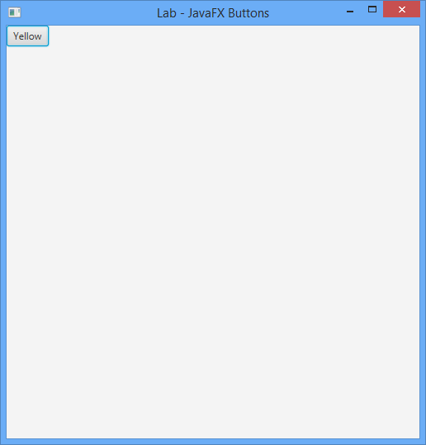

***Part 2 – More Buttons***

1. Add two Button members to the window. Call them Red and Green.
2. Add action handlers for each button in the start method. They should each respectively print “Red button pressed” or “Green button pressed”.
3. Run program. Press the buttons and make sure the correct messages show up in the console window.

Here is what it should look like:

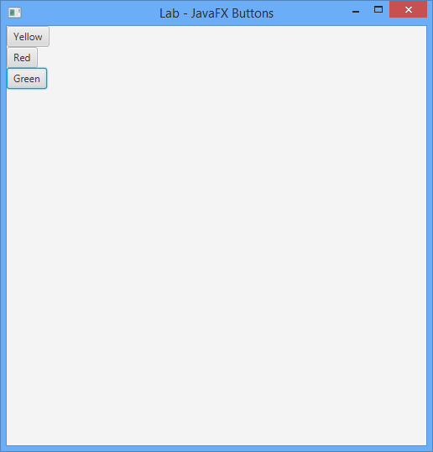

***Part 3 – Change Color***

Update the event handlers for each button so that they appropriately change the background color. You need to set the style on the root control to do this. The root control is the anchorpane. The following lines change the background color (assumes there is a variable declared named anchorpane):

anchorpane.setStyle("-fx-background-color: #FF0000;"); // Red – RGB code defines the color

anchorpane.setStyle("-fx-background-color: #00FF00;"); // Green – RGB code defines the color

anchorpane.setStyle("-fx-background-color: #FFFF00;"); // Yellow – RGB code defines the color

Here is what it looks like when Green is pressed:

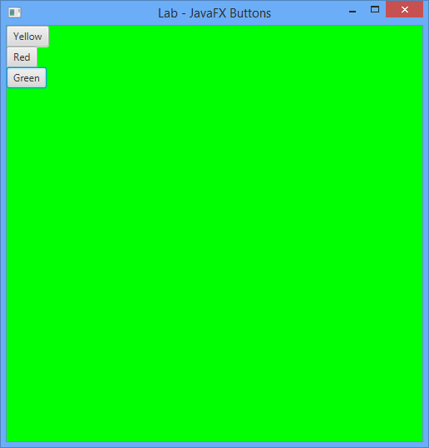

***Part 4 - ComboBox***

Add a ComboBox to the window. The ComboBox should have the items “Yellow”, “Red”, and “Green”.

1. Add the items “Yellow”, “Red”, and “Green” to the ComboBox.
2. Add an event handler for the ComboBox. The event handler should change the background color depending on the selected item.
3. Run program. Select each item and make sure the correct background color is displayed.

Here is what it looks like when the ComboBox is dropped down:

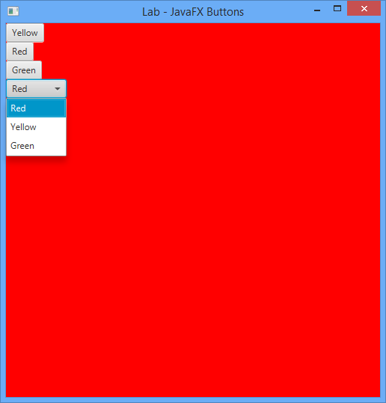

***Part 5 - Menu***

Create a window that uses a menu to set the background color of the window.

1. Add an FXML menu bar to the VBox pane **FIRST**. It needs to be the first child in the Pane (VBox in this case) or it will not show up at the top of the window.
2. Create an FXML menu inside the menu bar. The title of the menu should be “Color”.
3. Create FXML menu items for Red, Green, and Yellow. Add event handlers for each menu item. Each menu item event handler should appropriately change the background color.
4. Run the program. Check each menu item to make sure it functions properly.

Here is what it should look like:

